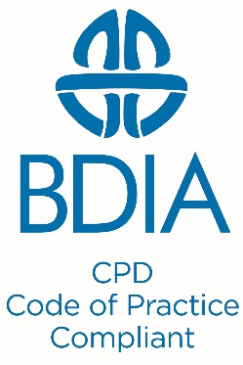

PDP AND ECPD ACTIVITY RECORDS
To help you comply with the General Dental Council requirements for registration as a dentist or dental care professional, the following templates have been designed for you to record your Personal Development Plan (PDP) and your Enhanced Continuing Professional Development (ECPD) activities.
- Below are guidelines on personal development plans and the GDCs development outcomes
- Record details of your personal development plan (Template 1)
- Record your enhanced CPD activity log (Template 2)
- Please adapt these templates to your personal requirements
PERSONAL DEVELOPMENT PLAN
- Identify your personal educational needs for the maintenance and development of professional knowledge and skills which are relevant to your current or future field of practice
- Identify the CPD activity/activities that will best help you address your educational needs and suit your learning style e.g. lectures, hands-on, etc
- Make sure that your planned CPD activity maps to at least one of the GDC’s four development outcomes (Table 1) (Remember there is no requirement to cover all of the development outcomes in each CPD cycle)
- Identify the expected timeframe for completion of the CPD activity
Table 1: GDC Development outcomes for CPD
A | Effective communication with patients, the dental team, and others across dentistry, including when obtaining consent, dealing with complaints, and raising concerns when patients are at risk
B | Effective management of self, and effective management of others or effective work with others in the dental team, in the interests of patients at all times; providing constructive leadership where appropriate;
C | Maintenance and development of knowledge and skill within your field of practice
D | Maintenance of skills, behaviours and attitudes which maintain patient confidence in you and the dental profession and put patients’ interests first.

Template 1: Personal Development Plan (PDP)
Name: XXXX
GDC registration number: XXXXX
Year: 20XX
PDP Ref/Code | Educational need(s) | Planned CPD activity/activities | GDC Development outcome(s) (A/B/C/D) | Timeframe for completion/  Target date

Template 2: Enhanced CPD Record
Name: XXXX
GDC registration number: XXXXX
Year: 20XX
Total CPD hours recorded below = xxx
PDP Ref/code  (From template 1) | Date | CPD Provider | Venue | GDC Development outcome(s)  (A/B/C/D) | CPD  Hours | Yes/No | REFLECTION e.g. identify  - What aspects of the training were most useful?  - What will you do differently?  - The knowledge, understanding, skills that have been reinforced/enhanced  - How patient care will be enhanced  - How practice quality will be enhanced  - Additional learning needs
Evidence
(e.g. Certificate)
 |  |  |  |  |  | Quality controls
 |  |  |  |  |  | Feedback opportunities
 | xx/xx/xx

